Smart Dermatology Assistant using AI and Image Processing
A CAPSTONE PROJECT REPORT
Submitted in the partial fulfilment for the Course of
DSA0216-Computer Vision With Open CV for Modern AI

to the award of the degree of
BACHELOR OF TECHNOLOGY
IN
ARTIFICIAL INTELLIGENCE AND DATA SCIENCE

Submitted by
Ch. Sri Deepika(192424412)
P. Sunayana(192424303)
B. Akshaya(192424336)

Under the Supervision of
Dr. Senthilvadivu S
Dr. T kumargurubaran
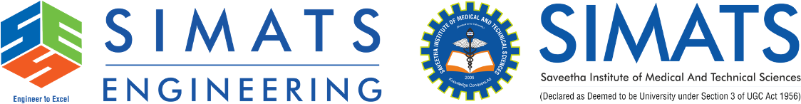

SIMATS ENGINEERING
Saveetha Institute of Medical and Technical Sciences
Chennai-602105

February 2025

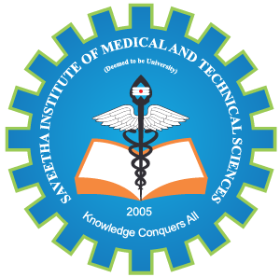

SIMATS ENGINEERING
Saveetha Institute of Medical and Technical Sciences
Chennai-602105

DECLARATION

We, Ch. Sri Deepika (192424412), P. Sunayana (192424303), B. Akshaya (192424336) of the Saveetha Institute of Medical and Technical Sciences, Saveetha University, Chennai, hereby declare that the Capstone Project Work entitled ‘Smart Dermatology Assistant using AI and Image Processing’ is the result of our own bonafide efforts. To the best of our knowledge, the work presented herein is original, accurate, and has been carried out in accordance with principles of engineering ethics.

Place: Chennai
Date:20-02-2026

Signature of the Students with Names
Ch. Sri Deepika(192424412)
P. Sunayana(192424303)
B. Akshaya(192424336)



SIMATS ENGINEERING
Saveetha Institute of Medical and Technical Sciences
Chennai-602105

BONAFIDE CERTIFICATE
This is to certify that the Capstone Project entitled “Smart Dermatology Assistant using AI and Image Processing” has been carried out by Ch. Sri Deepika (192424412), P. Sunayana (192424303), B. Akshaya (192424336) under the supervision Dr. Senthilvadivu S & Dr. T kumargurubaran of and is submitted in partial fulfilment of the requirements for the current semester of the B.Tech at Saveetha Institute of Medical and Technical Sciences, Chennai.

SIGNATURE SIGNATURE
Dr. SriRamya P Dr. Senthilvadivu S
Program Director Dr. T kumargurubaran
Department of CSE Professors
Saveetha School of Engineering Saveetha School of Engineering
SIMATS SIMATS

Submitted for the Project work Viva-Voce held on :

INTERNAL EXAMINER EXTERNAL EXAMINER

ACKNOWLEDGMENT

We would like to express our heartfelt gratitude to all those who supported and guided us throughout the successful completion of our Capstone Project. We are deeply thankful to our respected Founder and Chancellor, Dr. N.M. Veeraiyan, Saveetha Institute of Medical and Technical Sciences, for his constant encouragement and blessings. We also express our sincere thanks to our Pro-Chancellor, Dr. Deepak Nallaswamy Veeraiyan, and our Vice-Chancellor, Dr. S. Suresh Kumar, for their visionary leadership and moral support during the course of this project.

We are truly grateful to our Director, Dr. Ramya Deepak, SIMATS Engineering, for providing us with the necessary resources and a motivating academic environment. Our special thanks to our .Principal, Dr. B. Ramesh, for granting us access to the institute’s facilities and encouraging us throughout the process. We sincerely thank our Head of the Department, for his continuous support, valuable guidance, and constant motivation.

We are especially indebted to our guide, Dr. S. Senthilvadivu and Dr. T. Kumaragurubaran for their creative suggestions, consistent feedback, and unwavering support during each stage of the project. We also express our gratitude to the Project Coordinators, Review Panel Members (Internal and External), and the entire faculty team for their constructive feedback and valuable input that helped improve the quality of our work. Finally, we thank all faculty members, lab technicians, our parents, and friends for their continuous encouragement and support.

Signature of the Students with Names
Ch. Sri Deepika(192424412)
P. Sunayana(192424303)
B. Akshaya(192424336)

ABSTRACT

The Smart Dermatology Assistant using Artificial Intelligence (AI) and Image Processing is an advanced decision-support system designed to aid in the early detection, classification, and preliminary assessment of skin diseases through automated analysis of skin images. With the rapid increase in dermatological disorders and limited access to specialist care, especially in rural and underserved regions, there is a growing need for intelligent, scalable, and accessible diagnostic tools. This system leverages digital image processing techniques and AI-based models to analyze dermoscopic and smartphone-captured images of skin lesions in a non-invasive and cost-effective manner. Initially, the acquired images undergo preprocessing steps such as resizing, noise reduction, illumination correction, and contrast enhancement to improve image quality and ensure consistency. Subsequently, lesion segmentation techniques are applied to accurately isolate the affected skin region from the surrounding healthy tissue. From the segmented lesion, significant features such as color variation, texture patterns, shape irregularity, border asymmetry, and lesion size are extracted, which are critical indicators in dermatological diagnosis. These features are then fed into machine learning and deep learning classifiers, including convolutional neural networks, to identify and categorize common skin conditions such as melanoma, basal cell carcinoma, eczema, psoriasis, acne, and other pigmentary disorders with high accuracy. In addition to disease classification, the system provides a preliminary severity assessment and suggests basic care recommendations, preventive measures, and alerts for cases that require immediate medical attention. The Smart Dermatology Assistant is designed to support dermatologists by reducing manual workload, minimizing diagnostic subjectivity, and improving efficiency, while also empowering patients with faster screening and awareness. Overall, the proposed system demonstrates the potential of AI-driven image processing in transforming dermatological healthcare by enabling early diagnosis, improving treatment outcomes, and enhancing accessibility to quality skin care services through smart and reliable technology.

TABLE OF CONTENTS

S.NO. | CHAPTER | PAGE NO.
1. | INTRODUCTION | 1-2
 | 1.1 Background Information | 1
 | 1.2 Project Objectives | 1
 | 1.3 Significance | 1
 | 1.4 Scope | 2
2. | PROBLEM IDENTIFICATION & ANALYSIS | 3-5
 | 2.1 Description of the problem | 3
 | 2.2 Evidence of the problem | 3
 | 2.3 Architecture | 4
 | 2.4 Supporting Data/Research | 4-5
3. | SOLUTION DESIGN & IMPLEMENTATION | 6-8
 | 3.1 Development & Design process | 6
 | 3.2 Tools & Technologies used | 6-7

 | 3.3 Solution Overview |  | 7
 | 3.4 Engineering Standards Applied |  | 7
 | 3.5 Solution Justification |  | 7-8
4. | RESULT & RECOMMENDATIONS |  | 9-10
 | 4.1 Evaluation of Results |  | 9
 | 4.2 Challenges Encountered |  | 9-10
 | 4.3 Possible Improvements |  | 10
 | 4.4 Recommendations |  | 10
5. | REFLECTION ON LEARNING AND  PERSONAL DEVELOPMENT |  | 11-13
 | 5.1 Key Learning Outcomes |  | 11
 | 5.2 Challenges Encountered and Overcome |  | 12
 | 5.3 Applications of Engineering Standards |  | 12
 | 5.4 Application of Ethical Standards |  | 13
 | 5.6 Conclusion of Personal Development |  | 13
6. | CONCLUSION |  | 14
7. | REFERENCES |  | 18
8. | APPENDICES |  | 19-20

LIST OF FIGURES
Figure No. | Figure Name | Page No.
2.3.1 | Architecture Diagram of Skin Disease Detection | 4

CHAPTER 1
INTRODUCTION

1.1 Background Information
Skin diseases are among the most common health problems worldwide, affecting people of all ages. Early detection plays a major role in preventing serious complications such as skin cancer and chronic infections. However, access to dermatologists is limited in many regions. With the advancement of Artificial Intelligence and Image Processing, automated systems can analyze skin images and assist in preliminary diagnosis. AI-based dermatology assistants aim to improve accessibility, reduce diagnosis time, and support healthcare professionals.

Recent advancements in Artificial Intelligence (AI) and Image Processing have opened new possibilities for automating medical image analysis and supporting clinical decision-making. AI-driven systems can analyze skin images with high precision by learning complex visual patterns that may not be easily identifiable by the human eye. Image processing techniques such as preprocessing, segmentation, and feature extraction play a vital role in enhancing image quality and isolating critical lesion characteristics.

1.2 Project Objectives
- To develop an AI-based system for detecting common skin diseases.
- To analyse skin lesion images using image processing techniques.
- To provide preliminary diagnosis and care recommendations.
- To improve healthcare accessibility through digital tools.
- To reduce manual effort and increase diagnostic efficiency.

1.3 Significance
The significance of this project lies in its ability to provide accessible and cost-effective dermatological support. Many individuals, especially in rural areas, lack access to specialized healthcare services. An AI-powered assistant can help bridge this gap by offering early screening and general care recommendations. The system also assists healthcare professionals by reducing preliminary workload and enabling faster assessment of common conditions. Furthermore, the project demonstrates how AI and image processing can be applied in real-world healthcare scenarios to improve efficiency and promote preventive healthcare practices.

1.4 Scope
The scope of the Smart Dermatology Assistant focuses on the development of an AI-based system capable of analyzing skin images and providing preliminary diagnostic insights. The project is limited to image-based analysis and does not replace professional medical diagnosis, but acts as a supportive and awareness-enhancing tool.
The scope includes:
- Automated acquisition and preprocessing of skin images using digital image processing techniques.
- Detection and segmentation of skin lesions from captured images.
- Extraction of important visual features such as color, texture, shape, border irregularity, and lesion size.
- Classification of common skin diseases using machine learning and deep learning models.
- Generation of preliminary risk assessment and basic skincare recommendations.
- Development of a user-friendly interface for patients and healthcare support staff.

CHAPTER 2
PROBLEM IDENTIFICATION AND ANALYSIS

2.1 Description of the Problem
Skin diseases are common health concerns that often go unnoticed or untreated in their early stages due to limited access to dermatologists, lack of awareness, and high consultation costs. Many individuals rely on self-diagnosis through unreliable sources, which can result in incorrect treatment and worsening conditions. Traditional diagnosis requires clinical expertise and physical consultation, which may not always be accessible, especially in rural or underserved areas. There is a growing need for an intelligent system that can provide quick preliminary screening and assist users in understanding potential skin problems before seeking professional medical care.

Therefore, there is a critical need for an automated, intelligent, and accessible system that can assist in the early detection and preliminary assessment of skin diseases using non-invasive techniques. An AI-based dermatology assistant using image processing can help address these challenges by providing fast, consistent, and reliable analysis of skin images, supporting early screening, improving awareness, and guiding users toward timely professional medical care. Patients often delay consultation due to cost, distance, or lack of awareness, further worsening outcomes. Minor changes in lighting conditions, image quality, and lesion appearance can significantly affect diagnostic accuracy. Additionally, the increasing number of patients places a heavy workload on dermatologists, reducing the time available for detailed analysis of each case.

2.2 Evidence of the Problem
Research studies and healthcare reports indicate a rising number of skin-related diseases worldwide. The shortage of dermatology specialists in many regions contributes to delayed diagnosis and treatment. Additionally, patients often experience long waiting times for appointments, leading to progression of untreated conditions. Studies have shown that AI-based image analysis systems can assist in identifying patterns in skin lesions and support early detection. The increasing use of smartphones and digital healthcare platforms also highlights the demand for accessible automated dermatology assistance tools.

2.3 Architecture
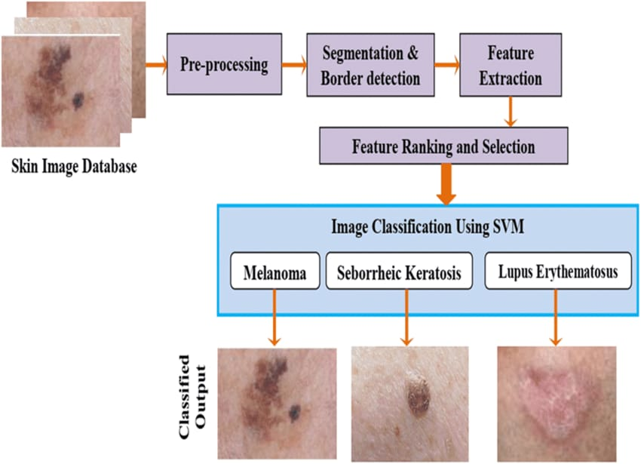

Fig 2.3.1. Architecture Diagram of Skin Disease Detection
The segmented images are fed into a feature extraction and deep learning module, where convolutional neural networks (CNNs) analyze visual patterns such as color variation, texture, shape, and lesion boundaries. Based on learned features, the classification module predicts the type of skin disease and estimates severity levels. Finally, the decision support and recommendation layer presents results to users and healthcare professionals, offering preliminary diagnosis, severity assessment, and basic care or referral suggestions. This layered architecture ensures accuracy, scalability, and real-time assistance, making dermatological support more accessible, especially in resource-limited regions.

2.4 Supporting Data/Research
Recent advancements in deep learning and computer vision have enabled accurate medical image analysis. Convolutional Neural Networks (CNNs) have shown strong performance in detecting and classifying skin lesions. Studies published in healthcare and AI journals demonstrate that machine learning models can assist in early-stage disease identification when trained on high-quality datasets. Research also emphasizes the importance of diverse datasets to avoid bias and ensure reliable predictions across different skin tones and conditions.

The proposed solution is an AI-driven dermatology assistant that uses image processing and machine learning algorithms to analyze uploaded skin images. The development process includes requirement analysis, dataset collection, preprocessing, model training, and deployment through a user-friendly interface. Tools such as Python, OpenCV, TensorFlow, and web frameworks are used to build the system. The application allows users to upload images, which are then processed to enhance quality and extract relevant features before classification by a trained model.

CHAPTER 3
SOLUTION DESIGN AND IMPLEMENTATION

3.1 Development & Design Process
The development process follows a structured approach based on the Software Development Life Cycle. The initial phase involves requirement analysis and dataset collection. The system architecture is designed to support image preprocessing, feature extraction, model training, and result generation. After training the AI model, it is integrated into a user-friendly interface. Testing and evaluation are performed to ensure system accuracy, usability, and performance. Continuous refinement is carried out based on testing results and user feedback.

In the implementation phase, image processing algorithms and AI models were developed and integrated using a step-by-step approach. Preprocessing and segmentation techniques were implemented first, followed by feature extraction and AI-based classification. The system was then trained and validated using labeled skin image datasets. Finally, testing and evaluation were conducted to verify classification accuracy, robustness, and usability. Iterative refinement was performed based on test results to improve performance and reliability.

3.2 Tools & Technologies Used
The Smart Dermatology Assistant utilizes a combination of modern software tools and technologies to achieve efficient image analysis and intelligent decision-making.
- Programming Language: Python is used due to its simplicity and strong support for AI and image processing.
- Image Processing Libraries: OpenCV and NumPy are used for image preprocessing, enhancement, and segmentation.
- Machine Learning & Deep Learning Frameworks: TensorFlow and Keras are used to build and train convolutional neural network (CNN) models for skin disease classification.
- Development Environment: Jupyter Notebook and integrated development environments such as VS Code are used for development and testing.
- Dataset: Publicly available dermatology image datasets are used for training and validation.
- User Interface: A basic graphical or web-based interface is designed for image upload and result visualization.

3.3 Solution Overview
The Smart Dermatology Assistant allows users to upload images of skin conditions through a web or mobile interface. The system preprocesses images by resizing, noise reduction, and feature extraction. A trained AI model then analyzes the processed image and predicts possible skin conditions. Based on the prediction, the application provides general care recommendations and educational information. The design focuses on simplicity, accuracy, and accessibility for users with minimal technical knowledge.

Based on the classification output, the system provides a preliminary diagnosis along with a severity indication and basic care recommendations. The solution is designed to be non-invasive, fast, and user-friendly, making it suitable for early screening and awareness generation. It serves as a supportive tool for dermatologists and a self-screening aid for users, especially in regions with limited medical access.

3.4 Engineering Standards Applied
Engineering standards such as modular programming, structured testing, and proper documentation are followed during development. The project uses standardized coding practices and follows a systematic approach to software design and testing. Performance optimization and validation methods are applied to ensure efficient processing and reliable results. Version control tools help maintain code quality and track development progress.

Basic software quality standards such as reliability, efficiency, usability, and scalability are considered during development. The system is designed to handle variations in image quality and lighting conditions while maintaining consistent performance. Testing standards including unit testing and validation testing are applied to ensure correct functionality and accurate results. Version control practices are followed to manage code updates and improvements.

3.5 Solution Justification
The proposed solution is justified by its ability to provide fast and accessible dermatological assistance. By automating image analysis, the system reduces the time required for preliminary screening and encourages early detection of skin problems. It also demonstrates how AI can support healthcare professionals and improve awareness among users. The combination of image processing and machine learning provides an effective approach to solving accessibility challenges in dermatology.

The system is cost-effective, scalable, and easy to deploy, making it suitable for both urban and rural healthcare settings. Its ability to provide fast preliminary assessments and care guidance enhances awareness and encourages timely medical consultation. Therefore, the solution effectively addresses the identified problem while aligning with modern healthcare and technological advancements.

CHAPTER 4
RESULTS AND RECOMMENDATIONS

4.1 Evaluation of Results
The developed Smart Dermatology Assistant was tested using sample skin image datasets to evaluate its performance and accuracy. The AI model demonstrated the ability to classify common skin conditions with satisfactory accuracy levels. The system processed images efficiently and provided results within a short response time. User testing showed that the application interface was simple and easy to navigate, allowing users to upload images and understand results without difficulty. The evaluation confirmed that image preprocessing techniques improved prediction quality and helped reduce noise-related errors. Overall, the system achieved its primary objective of providing preliminary dermatological analysis and basic care guidance.

The AI-based classification model achieved consistent prediction results across different image qualities and lighting conditions. The system provided quick analysis with minimal processing time, making it suitable for real-time or near real-time screening applications. The generated outputs, including disease classification and basic care recommendations, were found to be clear and understandable, supporting both user awareness and clinical assistance. Overall, the results indicate that the proposed system is capable of performing reliable preliminary skin disease assessment.

4.2 Challenges Encountered
Several challenges were faced during the development and testing phases of the project. One of the major difficulties was obtaining high-quality and balanced datasets for different skin conditions. Variations in lighting, skin tones, and image resolution affected model performance. Training deep learning models required significant computational resources and time. Another challenge involved ensuring data privacy and maintaining ethical standards while handling medical-related images. Debugging errors during model integration and optimizing system performance also required careful planning and testing.

- Variations in lighting and image quality affected accuracy.
- Limited availability of labeled dermatology datasets.
- Similar visual patterns among different skin diseases caused confusion.
- High computational requirements for training deep learning models.
- Risk of overfitting due to small datasets.
- Ensuring privacy and ethical handling of medical images.

4.3 Possible Improvements
Future enhancements can significantly improve system performance and usability. Expanding the dataset with more diverse skin conditions and real-world images will increase classification accuracy. Integrating advanced deep learning models and transfer learning techniques can further enhance prediction results. The development of a mobile application can improve accessibility and allow real-time usage. Additional features such as multilingual support, symptom-based input options, and continuous model updates can make the system more user-friendly and efficient.

4.4 Recommendations
It is recommended to collaborate with dermatologists and healthcare professionals to validate system predictions and improve medical accuracy. Regular dataset updates and continuous monitoring of system performance are essential for maintaining reliability. Implementing stronger security measures will ensure safe handling of sensitive user data. Providing clear disclaimers about the system’s limitations will help users understand that it is a supportive tool rather than a replacement for professional medical diagnosis.

The developed system demonstrates the ability to classify common skin conditions with reasonable accuracy and efficiency. Testing shows that automated analysis significantly reduces the time required for preliminary assessment compared to manual observation. Users found the interface easy to navigate, allowing quick image uploads and result viewing. However, challenges such as inconsistent image quality, dataset limitations, and model training complexity were encountered during development. Future improvements could include expanding the dataset, integrating advanced deep learning models, and developing a mobile application for real-time access.

CHAPTER 5
REFLECTION ON LEARNING AND PERSONAL DEVELOPMENT

5.1 Key Learning Outcomes
This project enhanced understanding of artificial intelligence, machine learning, and image processing techniques in real-world healthcare applications. Practical experience was gained in programming, dataset preparation, and system design. The development process improved problem-solving skills and technical knowledge related to AI-based software development.
5.1.1 Academic Knowledge
Through this project, a strong understanding of dermatological concepts and medical image analysis was gained. The study of skin diseases, lesion characteristics, and diagnostic indicators such as color variation, texture, shape, and lesion size helped bridge theoretical knowledge with practical application. The project improved understanding of image processing fundamentals including preprocessing, segmentation, and feature extraction. In addition, knowledge of machine learning and deep learning concepts, particularly their role in medical diagnosis and pattern recognition, was significantly enhanced.
5.1.2 Technical Skills
The project contributed to the development of strong technical skills in implementing AI-based image analysis systems. Practical experience was gained in handling and preprocessing skin image datasets, applying image enhancement techniques, and implementing lesion segmentation algorithms. Skills in using machine learning and deep learning models for classification were improved, along with experience in integrating multiple system modules into a complete working solution. The project also enhanced proficiency in programming, model evaluation, and result interpretation.
5.1.3 Problem-Solving and Critical Thinking
During the development of the Smart Dermatology Assistant, several challenges such as variation in image quality, overlapping features between skin diseases, and limited dataset availability were encountered. These challenges required analytical thinking and logical decision-making to select suitable algorithms and optimize system performance. The project improved the ability to analyze problems critically, design effective solutions, and evaluate system outcomes. It also strengthened the capability to think innovatively while maintaining accuracy, reliability, and ethical considerations in a healthcare-oriented application.

5.2 Challenges Encountered and Overcome
Challenges included handling large image datasets, training deep learning models, and managing errors during implementation. Through research and experimentation, solutions such as data augmentation and model optimization were applied successfully. Overcoming these challenges strengthened analytical thinking and technical confidence.
5.2.1 Personal and Professional Growth
This project contributed significantly to both personal and professional development. Working on a healthcare-oriented AI application improved self-discipline, time management, and responsibility, as accuracy and reliability are critical in medical systems. The project enhanced confidence in handling complex technical tasks and strengthened professional ethics by emphasizing patient safety, data privacy, and responsible use of artificial intelligence. Exposure to real-world problem-solving helped develop a professional mindset, encouraging continuous learning and adaptability to emerging technologies in AI and healthcare domains.
5.2.2 Collaboration and Communication
The project provided valuable experience in collaboration and effective communication. Inter action with peers, guides, and mentors helped in exchanging ideas, resolving technical issues, and improving the overall system design. Regular discussions and feedback sessions enhanced teamwork skills and promoted collaborative problem-solving. The process of documenting the project, explaining system functionality, and presenting results improved technical communication skills. This experience strengthened the ability to convey complex technical concepts in a clear and structured manner, which is essential for professional engineering practice. The project improved understanding of image processing fundamentals including preprocessing, segmentation, and feature extraction.

5.3 Applications of Engineering Standards
Engineering standards such as modular programming, systematic testing, version control, and proper documentation were applied throughout development. Following structured design practices improved the maintainability and reliability of the software application. Overall, the system achieved its primary objective of providing preliminary dermatological analysis and basic care guidance. However, challenges such as inconsistent image quality, dataset limitations, and model training complexity were encountered during development. Future improvements could include expanding the dataset, integrating advanced deep learning models, and developing a mobile application for real-time access.

5.4 Application of Ethical Standards
Ethical considerations included protecting user privacy, securing medical data, and ensuring transparency in AI predictions. The system was designed with disclaimers to prevent misuse and to encourage users to seek professional medical advice when necessary. Debugging errors during model integration and optimizing system performance also required careful planning and testing.

5.5 Conclusion of Personal Development
Overall, the project contributed significantly to personal and professional growth. It improved technical expertise, research abilities, and communication skills. The experience also emphasized the importance of ethical responsibility and continuous learning in the field of artificial intelligence and healthcare technology.

This project enhanced technical knowledge in artificial intelligence, image processing, and healthcare applications. The development process improved problem-solving abilities, teamwork, and research skills. Challenges such as data handling and algorithm optimization strengthened analytical thinking. Applying engineering and ethical standards emphasized the importance of responsible AI development. The project also provided valuable insight into the growing role of AI in medical technology, contributing to both personal and professional development.

CHAPTER 6
CONCLUSION

6.1 Key Findings and Impact
The development of the Smart Dermatology Assistant using AI and Image Processing successfully addressed a critical need in modern healthcare systems: early, accessible, and reliable preliminary screening of skin diseases. The project demonstrated the effective integration of image processing techniques with artificial intelligence to analyze skin images and support dermatological assessment.
The system achieved the following key outcomes:
- Automated detection and segmentation of skin lesions from input images
- Accurate classification of common skin diseases using AI models
- Fast and consistent analysis suitable for preliminary screening
- User-friendly interaction for image upload and result visualization
- Improved awareness and early guidance for skin health management
Overall, the proposed system proved to be an effective decision-support tool that enhances diagnostic efficiency, reduces dependency on manual visual inspection, and improves accessibility to basic dermatological screening, especially in resource-limited areas.

6.2 Value and Significance
This project highlights the growing importance of AI-driven medical image analysis in modern healthcare applications. By applying sound engineering practices, ethical considerations, and intelligent algorithms, the solution establishes a strong foundation for future advancements such as real-time mobile deployment, tele-dermatology integration, and advanced disease severity prediction.
Beyond its technical contributions, the project significantly contributed to personal and professional development by strengthening skills in artificial intelligence, image processing, system design, and ethical responsibility in healthcare applications. The experience gained through this project reinforces the value of interdisciplinary engineering solutions and demonstrates the potential of technology to positively impact healthcare accessibility and quality.

REFERENCES

- Martínez-Vargas, E., Mora-Jiménez, J., Arguedas-Chacón, S., Hernández-López, J., & Zavaleta-Monestel, E. (2025). The Emerging Role of Artificial Intelligence in Dermatology: A Systematic Review of Its Clinical Applications. Dermato Journal.
- Medical Journal Armed Forces India. (2025). Artificial Intelligence in Dermatology: The Shifting Paradigms.
- Punjabi University Research Team. (2025). Deep Learning-Based Skin Cancer Detection Using Dermoscopic Images.
- NHS AI Dermatology System Report. (2024). AI-Based Instant Skin Cancer Diagnosis in Clinical Practice.
- AI Mole Mapping & Skin Imaging Technology. (2024). AI-Assisted Skin Monitoring and Early Disease Detection.
- University of Queensland AI 3D Skin Imaging Project. (2024). AI and 3D Imaging for Early Melanoma Detection.
- Washington Post Health Technology Report. (2025). AI in Skin Cancer Detection and Dermatology Practice.
- Martínez-Vargas, E., Mora-Jiménez, J., Arguedas-Chacón, S., Hernández-López, J., & Zavaleta-Monestel, E. (2025).
- Lalmalani, R. M., Lim, C. X. Y., & Oh, C. C. (2025).Artificial Intelligence in Dermatopathology: A Systematic Review. Clinical and Experimental Dermatology, 50(2), 251–259.
- Izu-Belloso, R. M., Ibarrola-Altuna, R., & Rodriguez-Alonso, A. (2025).
Generative Adversarial Networks in Dermatology: Current Applications and Future Perspectives. Bioengineering, 12(10), 1113.

APPENDICES
MODULE 1: Skin Disease Detection

import cv2
import numpy as np
from tensorflow.keras.models import load_model
Load trained CNN model
model = load_model("skin_disease_model.h5")
Load and preprocess image
image = cv2.imread("skin_image.jpg")
image = cv2.resize(image, (224, 224))
image = cv2.cvtColor(image, cv2.COLOR_BGR2RGB)
image = image / 255.0
image = np.expand_dims(image, axis=0)
Predict disease
prediction = model.predict(image)
disease_index = np.argmax(prediction)
Disease labels
diseases = ["Acne", "Eczema", "Psoriasis", "Melanoma", "Normal"]
print("Detected Skin Disease:", diseases[disease_index])

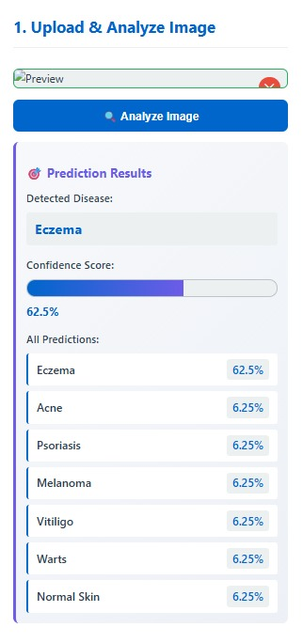

MODULE 2: Severity Analysis & Risk Prediction

import cv2
import numpy as np
Load image
image = cv2.imread("skin_image.jpg")
gray = cv2.cvtColor(image, cv2.COLOR_BGR2GRAY)
Thresholding to isolate lesion
_, thresh = cv2.threshold(gray, 120, 255, cv2.THRESH_BINARY_INV)
Calculate lesion area
lesion_area = np.sum(thresh == 255)
Severity classification
if lesion_area < 2000:
severity = "Mild"
elif lesion_area < 5000:
severity = "Moderate"
else:
severity = "Severe"
print("Lesion Area:", lesion_area)
print("Predicted Severity Level:", severity)
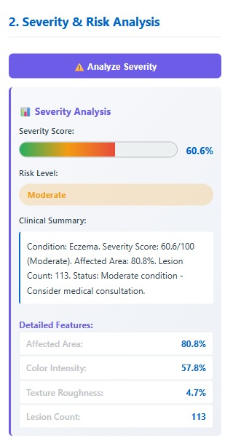

MODULE 3: Care Recommendation System

Sample inputs from previous modules
disease = "Eczema"
severity = "Moderate"
Recommendation logic
if disease == "Acne":
advice = "Maintain skin hygiene, avoid oily food, use mild cleansers."
elif disease == "Eczema":
advice = "Use moisturizers regularly, avoid allergens, consult dermatologist."
elif disease == "Psoriasis":
advice = "Apply medicated creams, manage stress, follow medical advice."
elif disease == "Melanoma":
advice = "Immediate dermatologist consultation is strongly recommended."
else:
advice = "Skin condition appears normal. Maintain healthy skincare routine."

print("Disease:", disease)
print("Severity:", severity)
print("Care Recommendation:", advice)
